**Comparison Report**

**Model Information:**

Model name: Alibaba-NLP/gte-Qwen2-1.5B-instruct

Max sequence length: 512 (Max: 8192)

Model Size: 1.5B

Embedding Dimension: 1536

Max Input Tokens: 32k

Size on disk: 6.62GB

**Testing Platform:**

Platform name: Google Colab

Device: CPU

**Test Basis:**

1. Using llama.cpp to convert tensors to .gguf file format
2. Using default model tensors

**Dataset Description:**

Number of queries: 10

Average query length: 65 characters

Number of documents: 10

Average document length: 410 characters

Language: Nepali

**Results:**

**Latency results**

|  |  |  |
| --- | --- | --- |
|  | **Using llama.cpp** | **Without llama.cpp** |
| **Query Embedding** | 62.399462s | 304.110372s |
| **Document Embedding** | 341.39s | 485.287s |

**Similarity results**

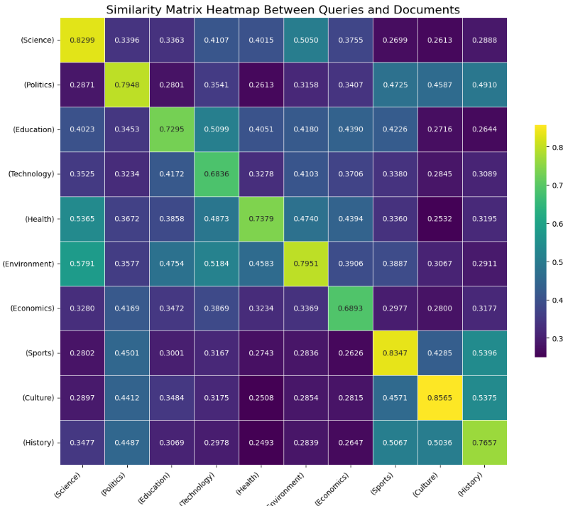

Fig: Without llama.cpp

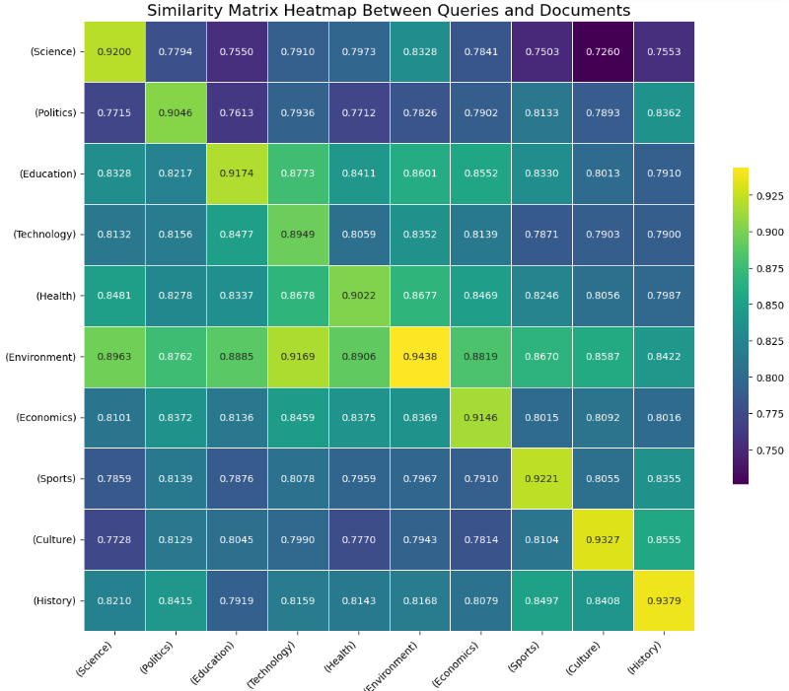

Fig: With llama.cpp (Using Mean pooling)

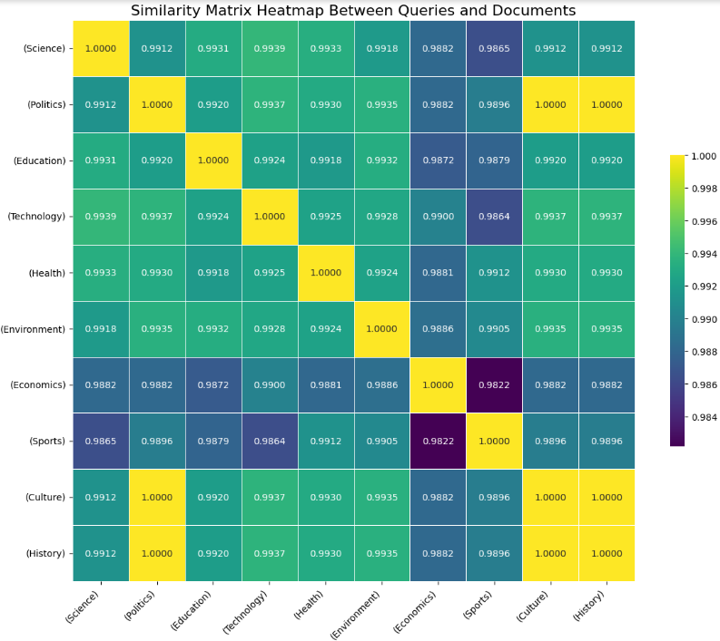

Fig: With llama.cpp (Using CLS pooling)